Chip back potential is the level which bulk silicon is maintained by on-chip connection, or it is the level to which the chip back must be connected when specifically stated below. If no potential is given the chip back should be isolated.

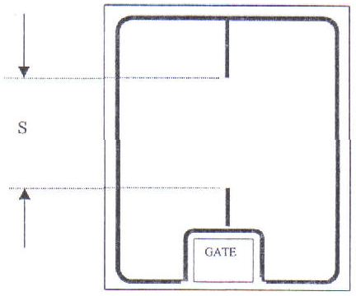

Source connection centrally between indicator lines: .057” Mils

Top Material: Al
Backside Material: CrNiAg
Bond Pad Size: Gate .020” X .025”
Backside Potential: Drain
Mask Ref: HEX 2.5 GEN 5

APPROVED BY: DK DIE SIZE .110” X .140” DATE: 8/30/21
MFG: IR THICKNESS .019” P/N: IRLC044
DG 10.1.2

Rev B, 7/19/02

